 Certificate of Occupancy
TOWN OF PLAINFIELD, NH

This certifies that the building owned by Town of Plainfield/Meriden Library at 22 Bean Road, Meriden, NH, 03770 may be occupied in accordance with the provisions of the 2021 International Building Code and the Codes of the Town of Plainfield.

Description of Structure: A 3600 square foot, single story library with two handicap bathrooms, small kitchen, meeting room, and library book room, replacing existing
library.

Portion of structure inspected: Completed library building.

Building Permit # 2021-67
Map/Lot: 104-23
Name: Town of Plainfield/Meriden Library
Address: 22 Bean Road
Meriden, NH 03770
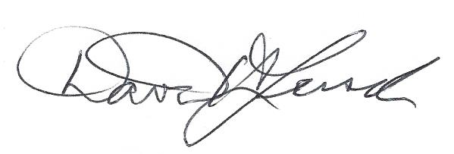 April 4, 2023 Building Code Official Signature Date
David H. Lersch

