 Certificate of Occupancy
TOWN OF PLAINFIELD, NH

This certifies that the building owned by Corin Craig at 235 Porter Road, Plainfield, NH, 03781 may be occupied in accordance with the provisions of the 2021 International Residential Code and the Codes of the Town of Plainfield.

Description of Structure: Construct a two story, 28'x42' single family two bedroom, two bathroom home with basement.

Portion of structure inspected: Completed single family home.

Building Permit # 2023-20
Map/Lot: 223-05
Name: Corin Craig
Address: 235 Porter Road
Plainfield, NH 03781
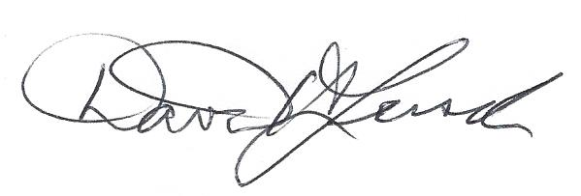 December 13, 2024 Building Code Official Signature Date
David H. Lersch

