 Certificate of Completion
TOWN OF PLAINFIELD, NH

This certifies that the building owned by Mac's Happy Acres, located at 259 River Road, Plainfield, NH 03781 is completed in accordance with the provisions of the 2021 International Building Code and the Codes of the Town of Plainfield.

Description of Structure: Add an 9'x30' addition to sugar house.

Portion of structure inspected: Completed addition.

Building Permit # 2023-46
Map/Lot: 219-01
Name: Mac's Happy Acres
Address: 259 River Road
Plainfield, NH 03781
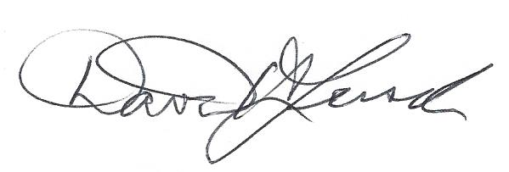 May 24, 2024

Building Code Official Signature Date David H. Lersch

