 Completion Certificate
TOWN OF PLAINFIELD, NH

This certifies that the work described by Building Permit # 2025-03 at 520 Willow Brook Road, Plainfield NH, Map/Lot 215-11 has been completed in accordance with the provisions of the International Residential 2021 Code and the Codes of the Town of Plainfield.

Description of Work: Install vehicle charger in garage.

Portion of structure inspected: Completed installation of charger.

Applicants Name: Andrew Martin
520 Willow Brook Road
Plainfield, NH 03781
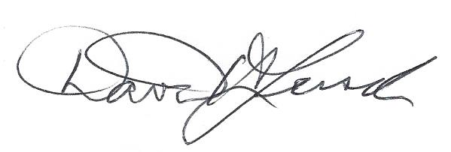
_________________________February 7, 2024
Building Code Official Signature Date
David H. Lersch

