Bill Taylor
billtatloylormvwd@gmail.com

04-16-20 I told Bill last winter that I would inspect his 12'x26' shed addition. Went by and inspected the shed addition with metal roof. Built with 6x6 posts buried in the ground and construction looked okay. I will issue a Certificate of Completion.
Time 0.6
David H Lersch
Plainfield Building Inspecto
 Completion Certificate
TOWN OF PLAINFIELD, NH

This certifies that the work described by Building Permit # 2019-62, at 58 Jenny Road, Meriden, NH, Map/Lot 215-25 has been completed in accordance with the provisions of the International Residential 2009 Code and the Codes of the Town of Plainfield.

Description of Work: Construct 14'x26' pole type shed addition to existing shed with gravel floor.

Portion of structure inspected: Completed garage.

Applicants Name: William S. Taylor
PO Box 44
Meriden, NH 03770
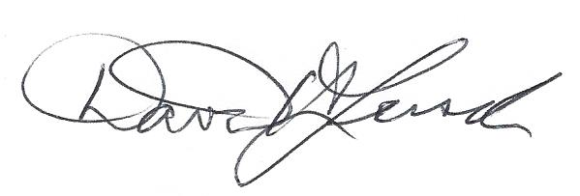 April 16, 2020
Building Code Official Signature Date David H. Lersch

