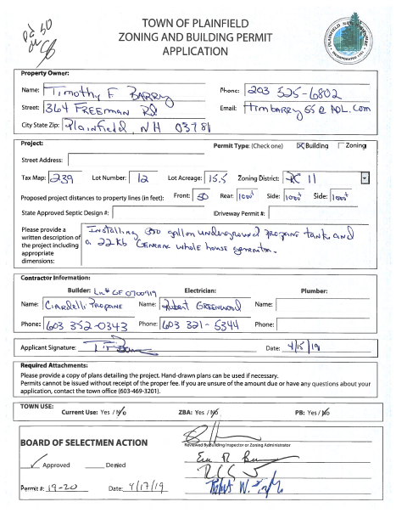
 DATE: 04/14/2020

Permit Status (Valid for one year from issue date)

Permit # 2019-20 Issued: 04-17-2019

_X__ RENEWAL REQUIRED BY __04___/__17__/__2020___

_X__ NO INSPECTION REQUESTED

____ LAST INSPECTION: NONE

_X___ YOUR PERMIT REQUIRED INSPECTIONS PER INSPECTION GUIDELINES.

____ CLOSED – YOUR PERMIT IS CLOSED, A NEW PERMIT IS REQUIRED

____ A CERTIFICATE OF OCCUPANCY WAS REQUIRED PRIOR TO OCCUPYIING YOUR HOUSE

__X_ A CERTIFICATE OF COMPLETION WAS REQUIRED

NAME: Timothy Barry
ADDRESS : 364 Freeman Road
Plainfield, NH 03781

MAP: 239 LOT 12 ADDRESS: Same
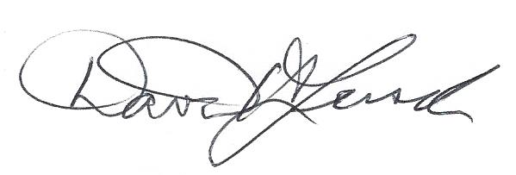
David H Lersch 603-381-1929
Plainfield Building Inspector
Timothy F Barry
364 Freeman Road
Plainfield
203-525-6802
Permit # 2019-20
Map/Lot 239-12
generator and buried propane tank

04-14-20 Sent renewal letter.

David H Lersch
Plainfield Building Inspector

