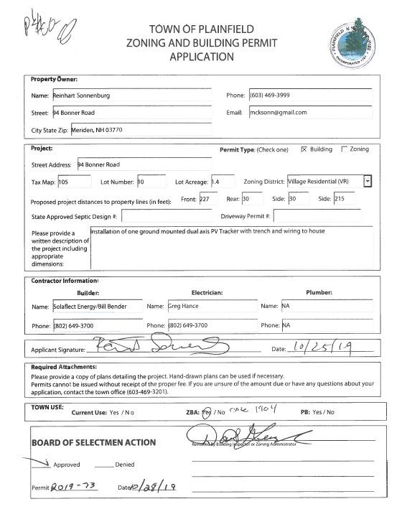
11-25-19 I inspected the trench, the concrete base and the pole with the electric panels wired for the ground mounted tracker solar.
Time .02
12-16-19

David,

Just to keep you in the loop, Brad Atwater completed the inspection for the electrical interconnection of the Solaflect Tracker at Reinhart Sonnenburg's property this morning. I've attached a copy of the Liberty Utilities sign off and hope that the utility will install the new net meter at the property shortly.

01-20-2020 Waiting for Brad's report, Issued Completion Certificate.

David Lutz | Solar Advisor | Solaflect Energy
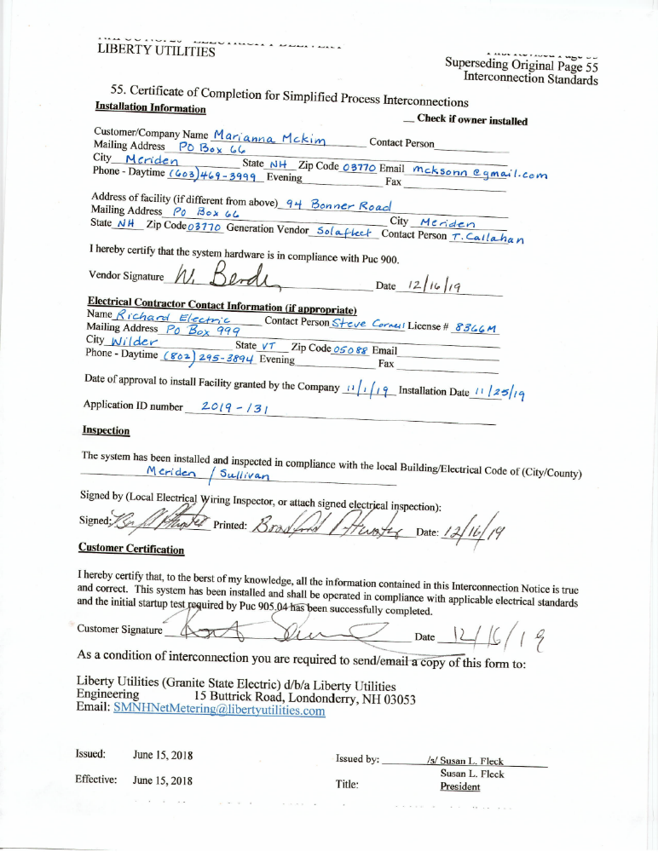

David H Lersch
Plainfield Building Inspector
 Completion Certificate
TOWN OF PLAINFIELD, NH

This certifies that the work described by Building Permit # 2019-73, at 94 Bonner Road, Meriden, NH, Map/Lot 105-10 has been completed in accordance with the provisions of the International Residential 2015 Code and the Codes of the Town of Plainfield.

Description of Work: Install ground mounted PV solar tracker system.

Portion of structure inspected: Installed and operational solar PV system.

Applicants Name: Reinhart Sonnenburg
94 Bonner Road
Meriden, NH 03770
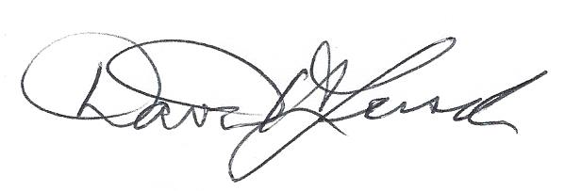 December 16, 2019
Building Code Official Signature Date David H. Lersch

